Evolutionary Process Model
The evolutionary model is based on the concept of making an initial product and then evolving the software product over time with iterative and incremental approaches with proper feedback. In this type of model, the product will go through several iterations and come up when the final product is built through multiple iterations. The development is carried out simultaneously with the feedback during the development. This model has a number of advantages such as customer involvement, taking feedback from the customer during development, and building the exact product that the user wants. Because of the multiple iterations, the chances of errors get reduced and the reliability and efficiency will increase.
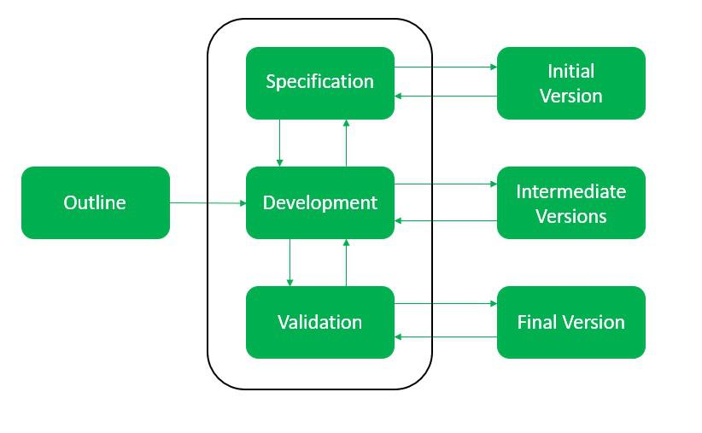
Evolutionary Model

Types of Evolutionary Process Models
- Iterative Model
- Incremental Model
- Spiral Model

Iterative Model
In the iterative model first, we take the initial requirements then we enhance the product over multiple iterations until the final product gets ready. In every iteration, some design modifications were made and some changes in functional requirements is added. The main idea behind this approach is to build the final product through multiple iterations that result in the final product being almost the same as the user wants with fewer errors and the performance, and quality would be high.
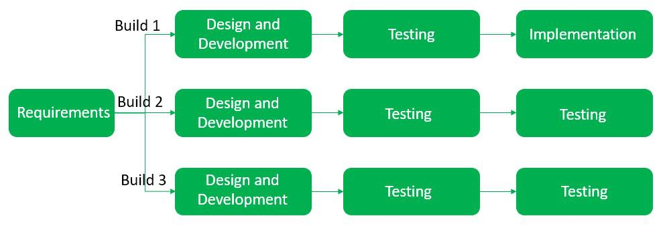
Iterative model

Incremental Model
In the incremental model, we first build the project with basic features and then evolve the project in every iteration, it is mainly used for large projects. The first step is to gather the requirements and then perform analysis, design, code, and test and this process goes the same over and over again until our final project is ready.
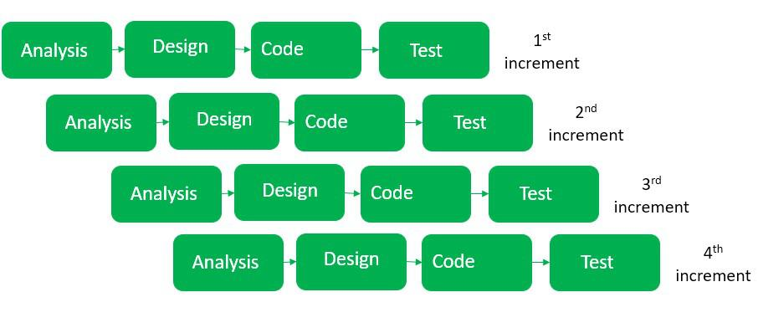
Incremental Model

Spiral Model
The spiral model is a combination of waterfall and iterative models and in this, we focused on risk handling along with developing the project with the incremental and iterative approach, producing the output quickly as well as it is good for big projects. The software is created through multiple iterations using a spiral approach. Later on, after successive development the final product will develop, and the customer interaction is there so the chances of error get reduced.
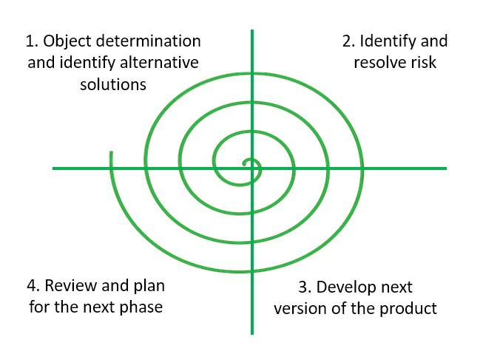
Spiral Model

Advantages of the Evolutionary Process Model
- During the development phase, the customer gives feedback regularly because the customer’s requirement gets clearly specified.
- After every iteration risk gets analyzed.
- Suitable for big complex projects.
- The first build gets delivered quickly as it used an iterative and incremental approach.
- Enhanced Flexibility: The iterative nature of the model allows for continuous changes and refinements to be made, accommodating changing requirements effectively.
- Risk Reduction: The model’s emphasis on risk analysis during each iteration helps in identifying and mitigating potential issues early in the development process.
- Adaptable to Changes: Since changes can be incorporated at the beginning of each iteration, it is well-suited for projects with evolving or uncertain requirements.
- Customer Collaboration: Regular customer feedback throughout the development process ensures that the end product aligns more closely with the customer’s needs and expectations.

Disadvantages of the Evolutionary Process Model
- It is not suitable for small projects.
- The complexity of the spiral model can be more than the other sequential models.
- The cost of developing a product through a spiral model is high.
- roject Management Complexity: The iterative nature of the model can make project management and tracking more complex compared to linear models.
- Resource Intensive: The need for continuous iteration and customer feedback demands a higher level of resources, including time, personnel, and tools.
- Documentation Challenges: Frequent changes and iterations can lead to challenges in maintaining accurate and up-to-date documentation.
- Potential Scope Creep: The flexibility to accommodate changes can sometimes lead to an uncontrolled expansion of project scope, resulting in scope creep.
- Initial Planning Overhead: The model’s complexity requires a well-defined initial plan, and any deviations or adjustments can be time-consuming and costly.

